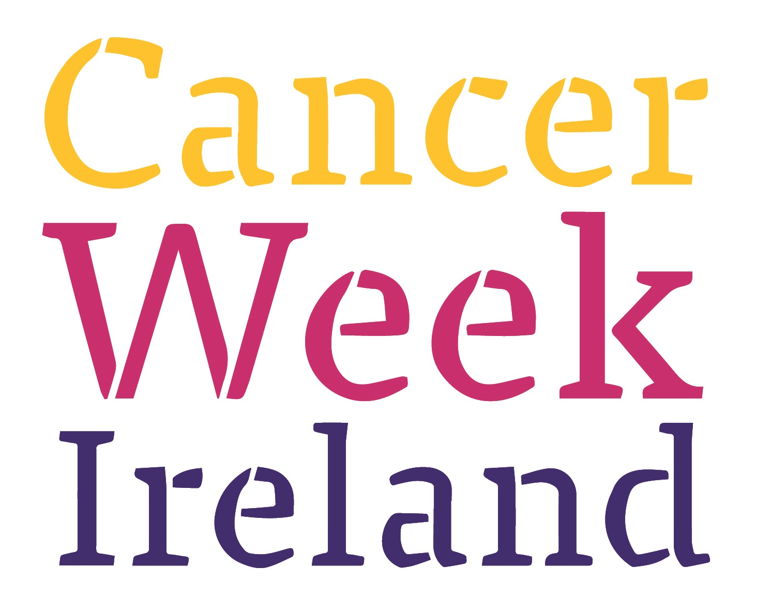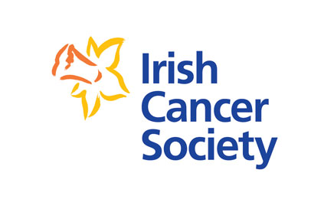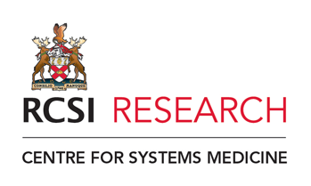

Mini-Symposium Monday 17th of Oct - in Cheyne Theatre @ 1-3 pm

Speakers

Prof. Ray Stallings
Prof. Jochen Prehn
Prof. Tracy Robson
Prof. Leonie Young
Dr. Brona Murphy
Dr. Triona Ni Chonghaile

Guest Speaker: Dr. Robert O’ Connor (Irish Cancer Society)

Everyone welcome to attend-no registration necessary

