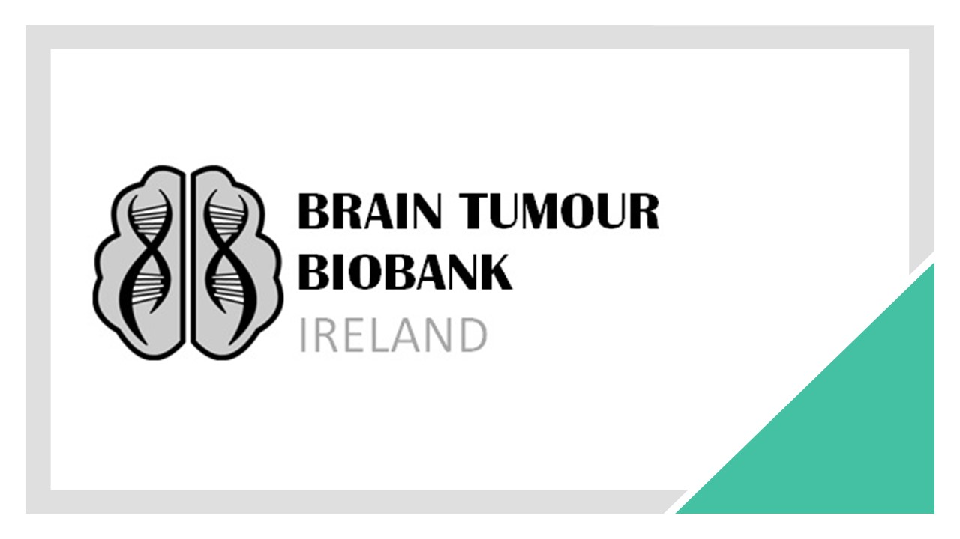

Appendix 1: Application Form to Brain Tumour Biobank

For Access to Biological Material and Data
Title of Project:

Name of Applicant(s):

Institution (s):

Principal Investigator:
Address:
Phone Number:
e-mail:

We/I hereby seek permission from Brain Tumour Biobank (BTB) to undertake the research work detailed in the attached proposal according to the conditions specified by the BTB. We/I will sign the BTB Material Transfer Agreement and will not distribute the material or data to third parties. We/I will list the “Brain Tumour Biobank” and “Brain Tumour Ireland” in the acknowledgements on any resulting publications and include any BTB member(s) who fulfil authorship criteria for the study as it progresses. We/I will meet the costs involved in preparing and shipping biological specimens and in extracting data from the central database. We/I realise that there is the potential that this human biological material may contain infectious agents, and therefore should be handled appropriately.

Signed: _____________________________________ Date: ____________

Signed: _____________________________________ Date: ____________

Signed: _____________________________________ Date: ____________

